**HARSHITHA H MOOLYA**

**118A1048 TE/CE/C3**

**EXPERIMENT NO-6**

# AIM : Use simulator NS2 to understand functioning of TCP and UDP.

**THEORY :**NS-2 stands for Network Simulator version 2.IT is a discrete event simulator for networking research. It work at packet level, provide substantial support to simulate bunch of protocols like TCP, UDP, FTP, HTTP and DSR. It simulate wired and wireless network. It is primarily UNIX based.Use TCL as its scripting language.

**CODE :**

# Create a simulator object

set ns [new Simulator]

#Define different colors for data flows (for NAM)

$ns color 1 Blue

$ns color 2 Red

#Open the NAM trace file

set nf [open out.nam w]

$ns namtrace-all $nf

#Define a 'finish' procedure

proc finish {} {

        global ns nf

        $ns flush-trace

        #Close the NAM trace file

        close $nf

        #Execute NAM on the trace file

        exec nam out.nam &

        exit 0

}

#Create four nodes

set n0 [$ns node]

set n1 [$ns node]

set n2 [$ns node]

set n3 [$ns node]

#Create links between the nodes

$ns duplex-link $n0 $n2 2Mb 10ms DropTail

$ns duplex-link $n1 $n2 2Mb 10ms DropTail

$ns duplex-link $n2 $n3 1.7Mb 20ms DropTail

#Set Queue Size of link (n2-n3) to 10

$ns queue-limit $n2 $n3 10

#Give node position (for NAM)

$ns duplex-link-op $n0 $n2 orient right-down

$ns duplex-link-op $n1 $n2 orient right-up

$ns duplex-link-op $n2 $n3 orient right

#Monitor the queue for link (n2-n3). (for NAM)

$ns duplex-link-op $n2 $n3 queuePos 0.5

#Setup a TCP connection

set tcp [new Agent/TCP]

$tcp set class_ 2

$ns attach-agent $n0 $tcp

set sink [new Agent/TCPSink]

$ns attach-agent $n3 $sink

$ns connect $tcp $sink

$tcp set fid_ 1

#Setup a FTP over TCP connection

set ftp [new Application/FTP]

$ftp attach-agent $tcp

$ftp set type_ FTP

#Setup a UDP connection

set udp [new Agent/UDP]

$ns attach-agent $n1 $udp

set null [new Agent/Null]

$ns attach-agent $n3 $null

$ns connect $udp $null

$udp set fid_ 2

#Setup a CBR over UDP connection

set cbr [new Application/Traffic/CBR]

$cbr attach-agent $udp

$cbr set type_ CBR

$cbr set packet_size_ 1000

$cbr set rate_ 1mb

$cbr set random_ false

#Schedule events for the CBR and FTP agents

$ns at 0.1 "$cbr start"

$ns at 1.0 "$ftp start"

$ns at 4.0 "$ftp stop"

$ns at 4.5 "$cbr stop"

#Detach tcp and sink agents (not really necessary)

$ns at 4.5 "$ns detach-agent $n0 $tcp ; $ns detach-agent $n3 $sink"

#Call the finish procedure after 5 seconds of simulation time

$ns at 5.0 "finish"

#Print CBR packet size and interval

puts "CBR packet size = [$cbr set packet_size_]"

puts "CBR interval = [$cbr set interval_]"

#Run the simulation

$ns run

**OUTPUT :**

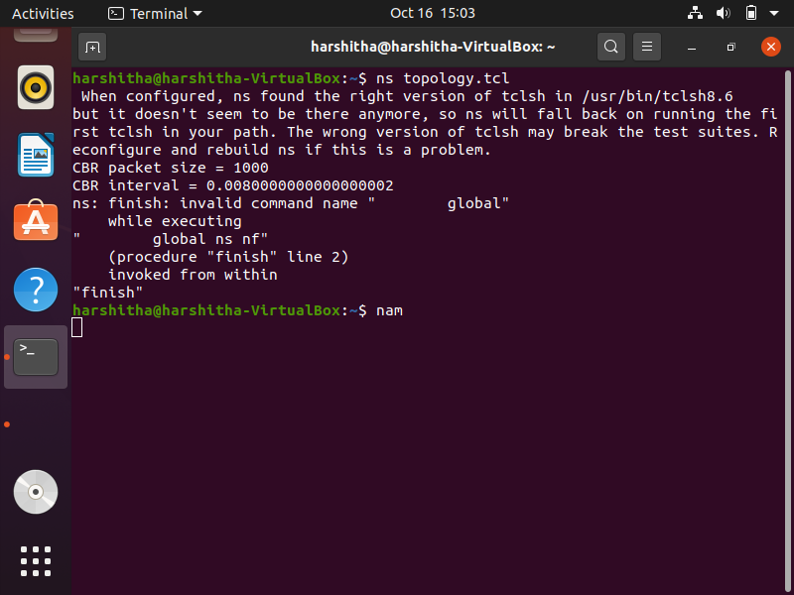

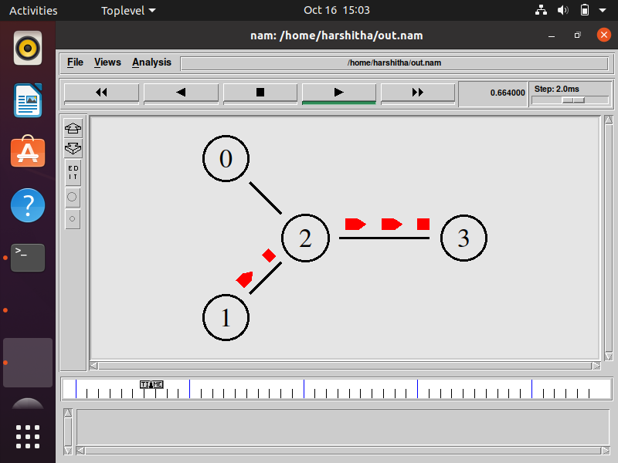

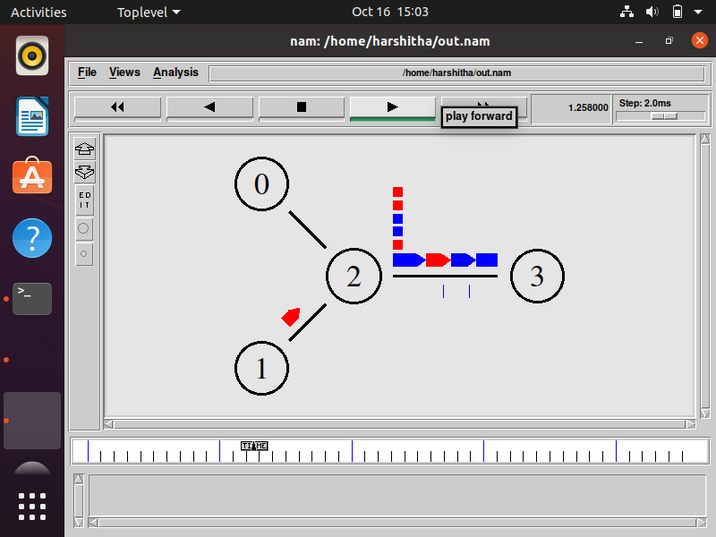

**CONCLUSION :** The above program has been implemented and executed successfully.